

**BOOKING INFO**

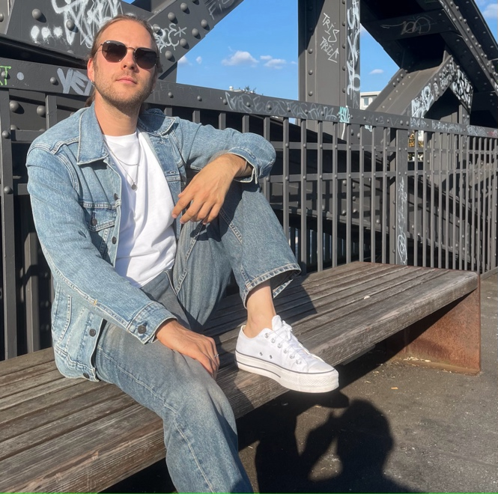

[DOWNLOAD HIGH-RESOLUTION IMAGES](https://www.ifmusicofficial.com/press/)

!F. I’m writing Songs for Lonely People and Overthinkers.

We create every moment in our lives with our choices, even if we choose not to choose. Most of the time, we take the safe route with our plans, goals, and directions instead of just letting go and losing ourselves in the beauty of the moment. At least, that‘s what I do most of the time and I always ask myself, what if I chose to do things different this time? The urge to break out of the system and not give a fuck always lingers round the corner. In one word, I overthink. All. The. Time.

What if we chose to enjoy some moments together on a journey between winning or losing, living up to or breaking with expectations, being stuck on the road or driving along, planning out every little detail, or just enjoying the ride without thinking about consequences or a goal-all at the same time? Just dreaming a little bit and having a look at what could be instead of what is. It might be a bumpy ride and not everything will work out, but at least there are opportunities and the taste of freedom. Nothing’s set in stone. Make it up on the go. Think later. This is what !F stands for.

!F is a minimalistic singer songwriter from Cologne, who blends catchy melodies with personal, poetic, and conversational lyrics about love, loneliness and self-doubt. Influenced by pop, rock and folk, the music can sound warm and welcoming, but also melancholic or even raw at times. While it can be playful with intimate and quiet or expressive and louder moments, it‘s always focused on emotion rather than virtuosity.

!F’s debut release, Home, is a poetic meditation about arriving and letting go at the same time. It brings feelings of welcome and letting go at the same time with a hint of jazz and a melancholic mood. It was the first thing that poured out of me on my last holiday. I was thinking of a good friend, that I’ve lost contact to a little bit and at the same time I had this warm feeling of arriving, which creates its special atmosphere.

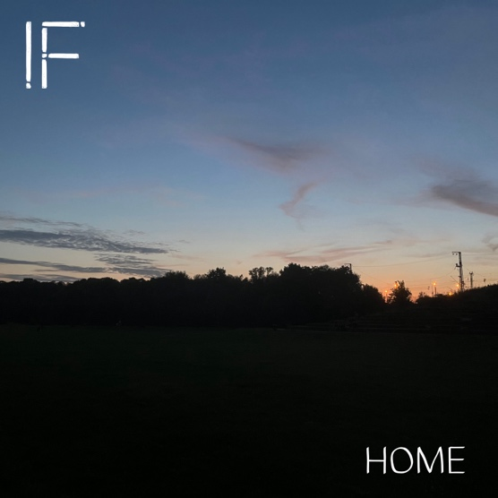

[DOWNLOAD HIGH-RESOLUTION IMAGES](https://www.ifmusicofficial.com/press/)

You can book !F for all kinds of shows, from headlining to support setups with several artists.

!F sings and plays with acoustic guitar, no overdubs/Ableton Tracks. Due to the minimalistic setup, !F can fit on very small stages.

Please contact us for technical details/catering/merch table.

Contact for details:

Benjamin Marschner

+49 176 25322490

[booking@ifmusicofficial.com](mailto:booking@ifmusicofficial.com)

Connect with !F

[Website](https://www.ifmusicofficial.com/) [Instagram](https://www.instagram.com/followifhere/) [TikTok](https://www.tiktok.com/@followifhere) [X](https://x.com/followifhere) [Facebook](https://www.facebook.com/followifhere) [Snapchat](https://www.snapchat.com/add/followifhere) [YouTube](https://www.youtube.com/@followifhere) [Spotify](https://open.spotify.com/intl-de/artist/5Jj3bz4CqVC1t33LiCAKbZ?si=bRDXGkYsTfSqm0H3dWv9Ew) [Apple Music](https://music.apple.com/de/artist/f/1770039099)